

**MACRO / VBA TOOL:**

VBA Line Number Generator



# Revision History Page

|  |  |  |  |
| --- | --- | --- | --- |
| **Date** | **Version** | **Description** | **Author/s** |
| 9/19/2019 | 1.0 | Initial creation | Ron Arbiel S. Tumandao |

# Description

This macro or VBA tool was designed to generate line numbers on each line of your VBA code which is useful for error handling. It can also remove line numbers, copy and paste the code without affecting the syntax.

# Platform Used

Microsoft Excel 2016

# Prerequisites:

1. Put two single quotes first where you want to end your VBA line numbers. Example: Err_Handler: ‘’
2. You can add any codes exception but not space as a criterion on Sheet: VBA Line Code Exception under Column: Line Code Exception
3. To add a comment in the right side of your code, it’s better to use “: REM” than ‘(single quote) so that you can insert a line number in that code.

## Visual Basic for Application

|  |  |  |
| --- | --- | --- |
| **Variables of AutoCorrect ()** | **Type** | **Description** |
| strValue | String | Copied strings from VBA code |
| FirstChar | String | First character of each line of code |
| SecondChar | String | Second character of each line of code |
| LastRow | Integer | Total used range of column C in sheet: “Paste Your VBA Code Here” |
| i | Integer | Row Number in excel in worksheet (Paste Your VBA Code Here) |

|  |  |  |
| --- | --- | --- |
| **Variables of CopyCode ()** | **Type** | **Description** |
| LastRow | Integer | Total used range of column C in sheet: “Paste Your VBA Code Here” |

|  |  |  |
| --- | --- | --- |
| **Variables of DeleteLineNumbers ()** | **Type** | **Description** |
| counter | Integer | Total Number of first character of each line of code that is numeric |
| strValue | Integer | Strings from VBA code |
| FirstChar | String | First character of each line of code that is numeric |
| LastRow | Integer | Total used range of column C in sheet: “Paste Your VBA Code Here” |
| i | Integer | Starting and next number for For Loops |
| index | Integer | Starting and next number for For Loops |

|  |  |  |
| --- | --- | --- |
| **Variables of CodeLineNumbering ()** | **Type** | **Description** |
| code | Range | Range of entire copied strings from VBA code |
| firstAddress | String | Cell address in sheet: (Paste Your VBA Code Here) |
| counter | Integer | Line number of each VBA code |
| strValue | String | Strings from VBA code |
| FirstChar | String | First character of each line of code |
| LastRow | Integer | Total used range of column C in sheet: “Paste Your VBA Code Here” |
| LastRow2 | Integer | Total used range of column C in sheet: “VBA Line Code Exception” |
| i | Integer | Starting and next number for For Loops |
| codeFlag | Boolean | Returns true if conditions met else false |

1. 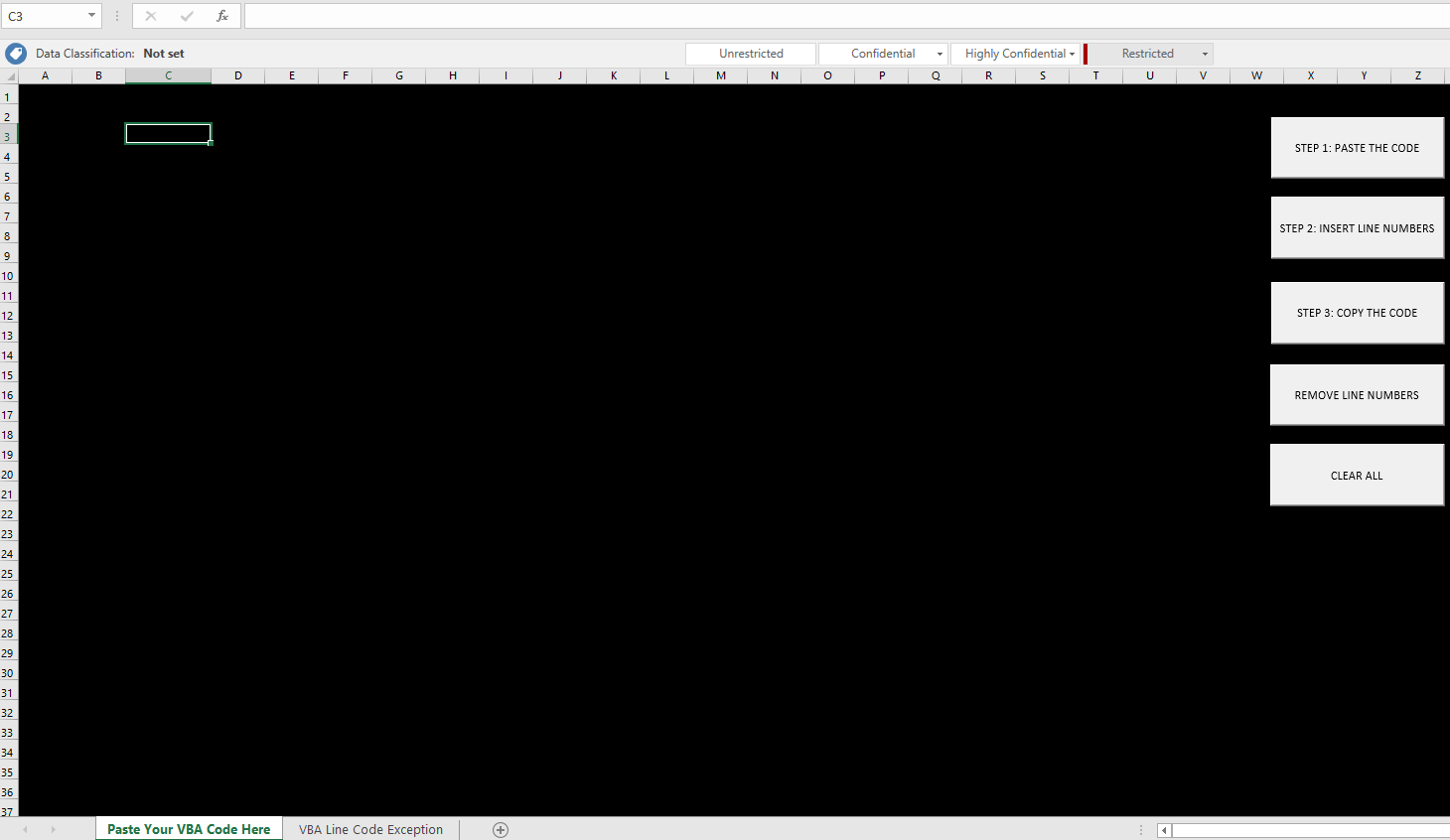**Open Spreadsheet (VBA Line Number Generator.xlsm)**
2. 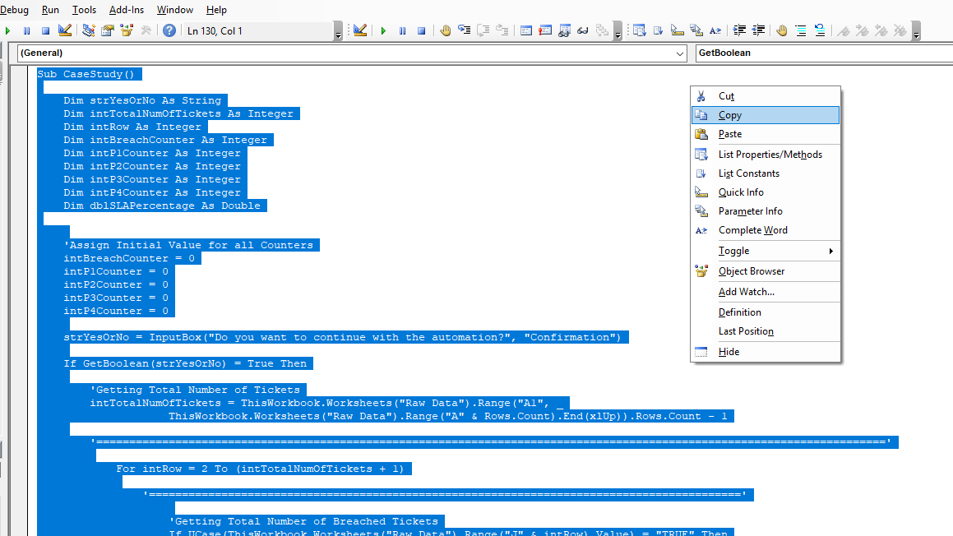**Copy your VBA code**
3. **Click “PASTE THE CODE” button to paste your VBA code**

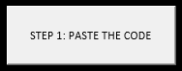

1. **Click “INSERT LINE NUMBERS” button to generate line numbers**

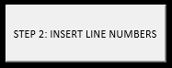

1. **Click “COPY THE CODE” button to copy your VBA code with line numbers**



1. **Click “REMOVE LINE NUMBERS” button to remove all line numbers**



1. **Click “CLEAR ALL” button to clear all contents in current sheet**



# Error Handling

*********************************************************************

**VBA/Macro**

*********************************************************************

On Error GoTo Err_Handler

VBA Code in this area…

Err_Handler:

If **Err.Number** > 0 Then

MsgBox "Something is wrong. " & **Err.Description** & " in line number: " & **Erl**, vbCritical, " Error: " & **Err.Number**

End If

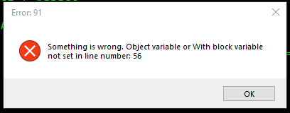

# Calibration Guide

The user can change, delete or add any line of codes exception in “VBA Line Number Generator.xlsm” spreadsheet inside “VBA Line Code Exception” worksheet under “Line Code Exception” column (A) but not space. If the user wanted to delete all line of codes exception, make sure to enter at least one-line code exception to make it work.

